Assignment :

ROLL NO :213064

NAME : Khansa

Class :BSCS-5

* Create you Local Repository and your Repository must contain the files index.html and app.js.

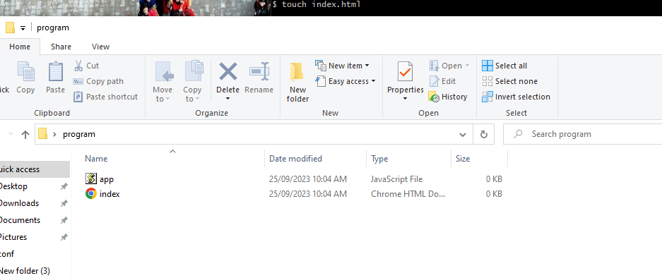

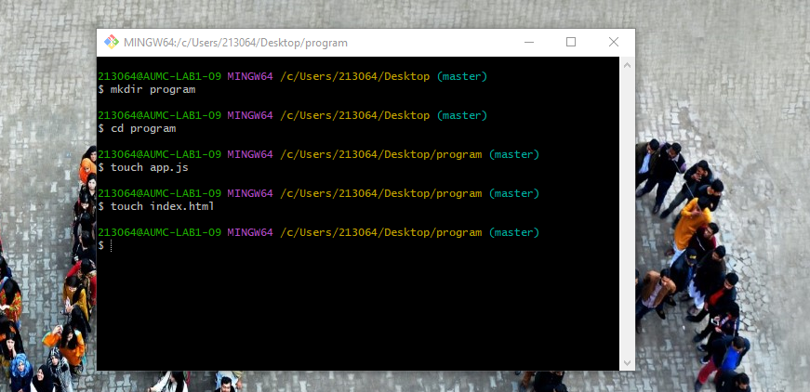

* Apply the commands for working on three Tree Architecture, show the screenshot of your bash while applying modifications one after add and other after commit.

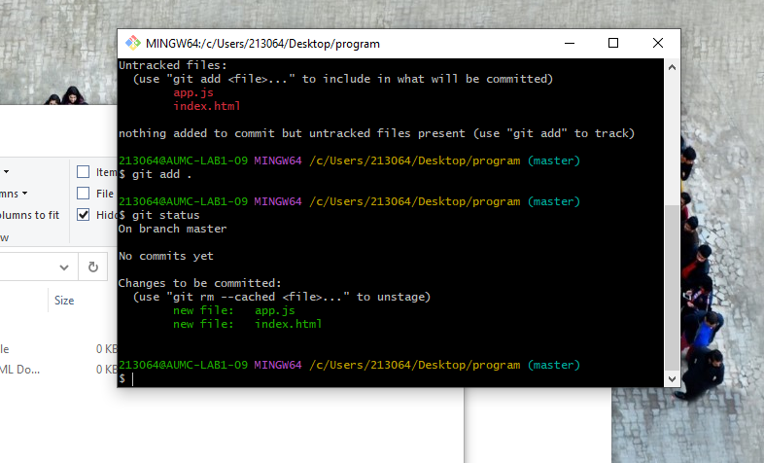

* Push Your Local Repository onto remote directory using the commands learned in class.

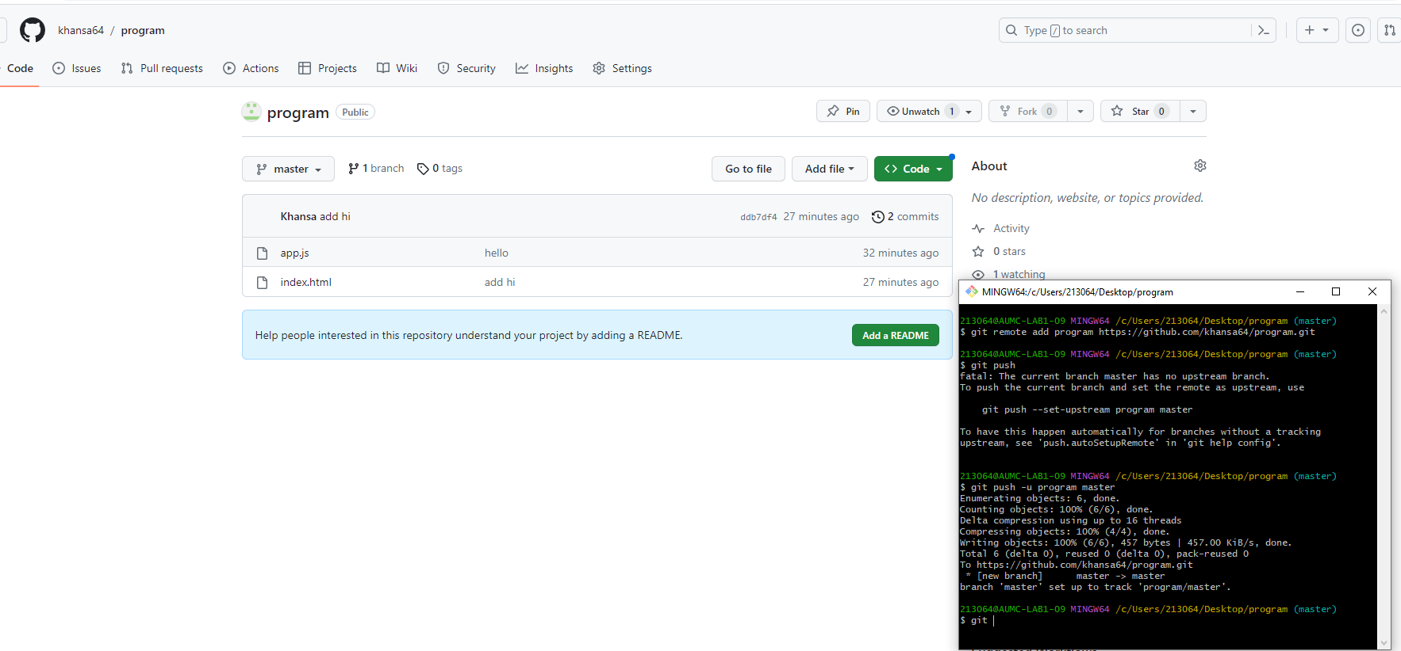

* Your repository must contain more than 02 commits and 1 branch.

